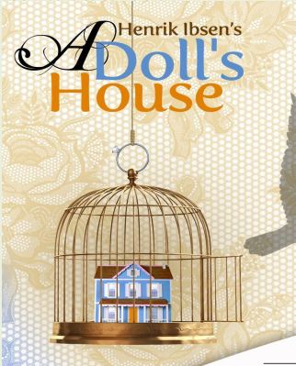
Contract for your study of Henrik Ibsen’s A Doll’s House
- Read the play in its entirety.
- Answer in strong-answer format all of the high-level study questions about the play.
- Take all quizzes that, together, average the letter grade you wish to receive.
- Read handouts and webpages, view power points and videos, and take class notes to learn about the Victorian period and the attitudes about men and women during that time.
- Create an original political cartoon in which you satirize the treatment of women during the Victorian period.
- Read two reviews of recent revivals of the play and work in a group to present to the class the highlights of the reviews.
- Choose a significant scene, get MCG approval, select classmate(s) to act out the scene with you, and act out the scene for the class. You do not have to memorize your lines, but you must be so familiar with them that you deliver your lines in character and with excellent articulation, perfect pronunciation of each word, and ample volume. Bring in props and costumes. Gulledge Emmys will be awarded.
- Write an essay (1 ½ to 2 pages in length) which explains the ways Ibsen uses three ordinary objects as symbols of Nora’s role as a doll and oppressed woman. The essay should be typed in MlA format.
- Craft an original claim (thesis statement) and a “logic outline” for a second potential essay about A Doll’s House. (See handout entitled “Essay Assignment II.”) Note: If you are struggling to create your own claim, you may use or tweak the suggested claims/thesis statements on the handout. You may also consider looking at the ways the play reflects the collective views of Victorian society and demonstrates the influence of such attitudes on the Victorian individual.
- Using your notes and the text of A Doll’s House as your primary resources, write the essay from the claim and outline you created for “I” above. Essay should be at least two typed pages in MLA format.
- Prepare an argument for a debate in class. Using your knowledge of the Victorian period, you will take one of the following roles:
- Assume the voice (the beliefs) of Helmer and defend his position as master of his household and his beliefs that women should be controlled by men and should exist to bring happiness to their husbands. Your proof should consist of examples from the text, legal rights/restrictions for Victorian men and women, and specific details about male and female attitudes towards women during the Victorian period.
- Assume the voice (the beliefs) of Nora—before she has her awakening—and defend her position as doll and secondary citizen who adopts the ideas and opinions of her husband. Your proof should consist of examples from the text, legal rights/restrictions for Victorian men and women, and specific details about male and female attitudes towards women during the Victorian period.
- Assume the voice of Christine Linde and attack Helmer’s attitudes towards Krogstad and defend the illegal behavior of Krogstad. Likewise, attack Helmer’s illusions about Nora and Nora’s efforts to keep her secrets from Helmer. Your proof should consist of examples from the text, legal rights/restrictions for Victorian men and women, and specific details about male and female attitudes towards women during the Victorian period.
- Assume the voice of Nora—after she has her awakening—and attack the ways Helmer has controlled her and criticized her during their whole married life. Include the ways his treatment of her has hurt her own development as a free-thinking individual. Your proof should consist of examples from the text, legal rights/restrictions for Victorian men and women, and specific details about male and female attitudes towards women during the Victorian period.

- Assume the voice of Torvald Helmer and imagine what he understands by the end of the play that he hasn’t understood before. As if you are Helmer, write a letter to Nora, expressing the way that you now see women and marriage differently. Your proof should consist of examples from the text, legal rights/restrictions for Victorian men and women, and specific details about male and female attitudes towards women during the Victorian period.

HONORS Students
To make an A: Complete A, B, C, D, E, F, G, H, I, J Complete either K or L

To make a B: Complete A, B, C, D, E, F, G, H, I Complete either K or L

To make a C: Complete A, B, C, D, E, H, L Complete G or K

ACADEMIC Students
To make an A: Complete A, B, C, D, E, F, G, H, I Complete either K or L

To make a B: Complete A, B, C, D, E, H, L Complete G or K

To make a C: Complete A, B, C, D, E, H, L

